When we returned the next weekend we were greeted with a surprise. Susan had talked to the rest of the fair board and they were so impressed at our success the previous weekend that they had given us the entire front patio of the community building to present our robots. With the extra space, we called in another FTC team, 5011 Bot Squad, and another FRC team, 5012 Griffin Gear. Our new location was right next to the front gate through which hundreds of people passed each hour. We also could now be more interactive with our audience by dropping our Star Trek Tribbles into their hands with our robot.
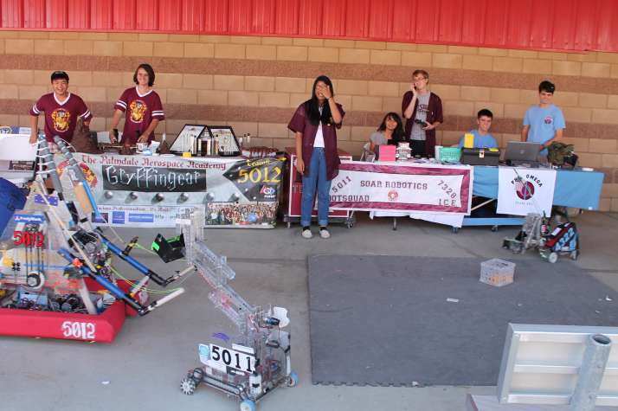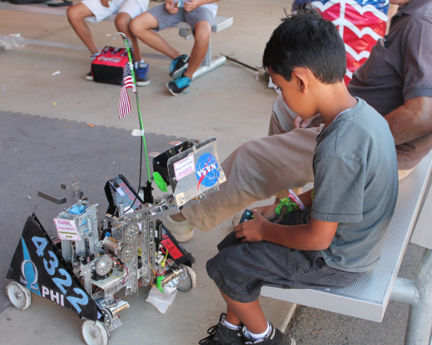
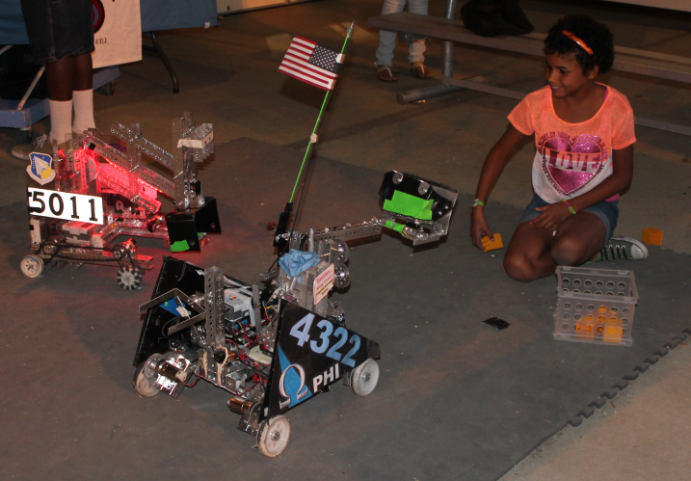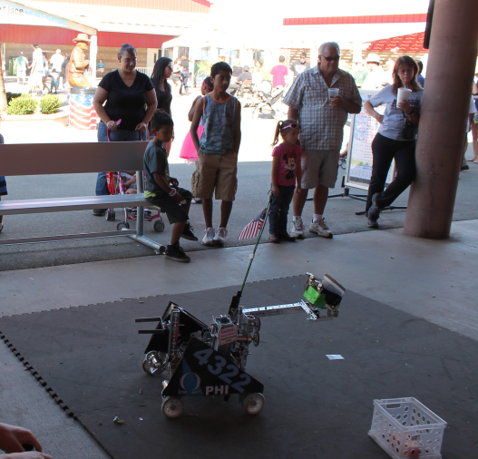
By the end of the fair we had handed out Tribbles and fliers to several hundred people and had encouraged several families to become involved in FIRST. The fair organizers where so impressed at our performance that they have invited us to come back again next year and they even promised us some display cases for a static display. The Antelope Valley Fair outreach has been by far our most successful and impacting outreach.

MENTOR HELP

Over the summer, we noticed that there were many kids that wanted to join robotics teams, but couldn’t due to a lack of open spaces, a lack of teams, or even a lack of mentors. We decided to help out by volunteering our knowledge at a mentor school.

THURSDAY NIGHT ON THE SQUARE

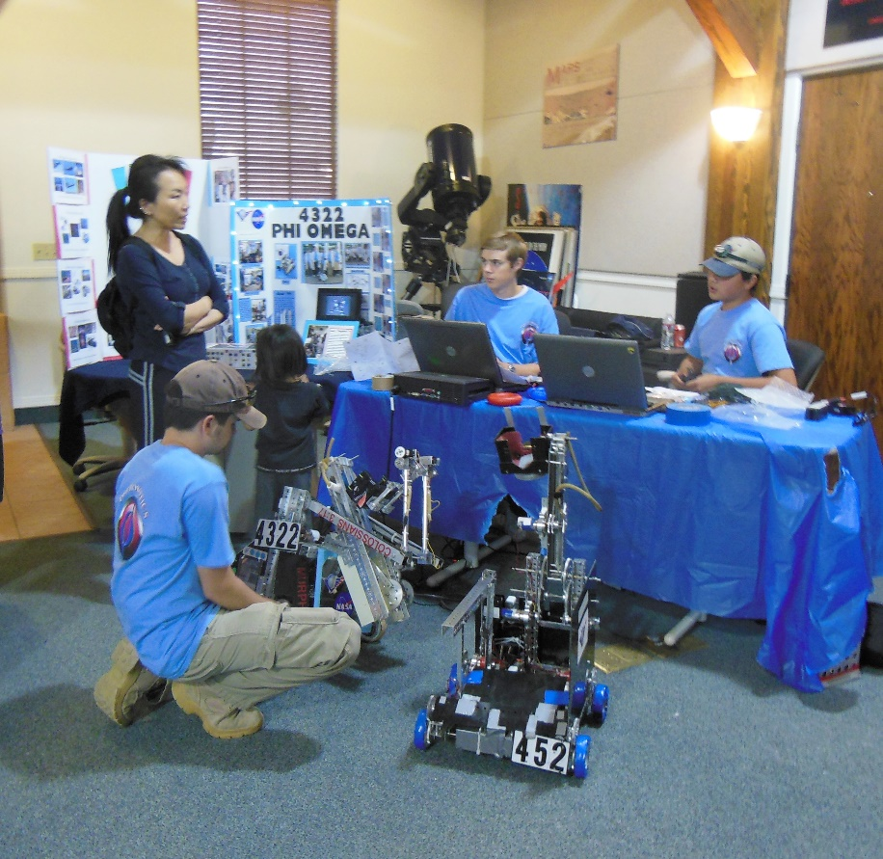
Phi Robotics did a demonstration at Thursday Night on the Square- a local event where organizations can set up booths and put up displays of their organizations. The event runs from 5:30 to 8:00 PM on Thursday evenings in the summer. A few other local FTC teams, namely GarageBots and the Palmdale Aerospace Academy, also participated in the robotics display, as well as two FRC teams. The teams got the chance to share with visitors about robotics and explain what it is that teams do each year. These visitors ranged in age from young children to adults. They handed out FIRST flyers, explained the different age groups and their leagues. They also explained how the 2013-2014 game Block Party worked, and demonstrated how their robots from that season could pick up blocks and score them. Small LEGO robots were also there for children to drive. Both teams- Phi Alpha and Phi Omega- participated in the event and got the chance to show their robot to those who came in. Over three hundred people visited the robotics display and showed a lot of interest in the display.

